INTRODUCTION

­­­­­­­­In the complex world of computer networking, seamless communication between devices relies on efficient address resolution. The Address Resolution Protocol (ARP) and Reverse ARP (RARP) are crucial protocols that bridge the gap between logical IP addresses and physical MAC addresses.

This project aims to simulate these protocols using Cisco Packet Tracer to gain a practical understanding of their operation. By configuring a simplified network topology and initiating communication between devices, we can capture and analyze network traffic to observe the exchange of ARP and RARP requests and replies.

Through this hands-on approach, we can delve into the step-by-step process of address resolution, from initial broadcast requests to targeted responses.

By the end of this project, we will have a solid grasp of network fundamentals and the practical application of ARP and RARP in real-world network scenarios.

METHODOLOGY

**1. Network Topology Design:**

* **Simple Network:** Create a basic network topology consisting of two end devices (e.g., PCs) connected to a switch.
* **IP Address Assignment:** Assign unique IP addresses to each end device.

**2. Cisco Packet Tracer Configuration:**

* **Device Configuration:** Configure the end devices with the assigned IP addresses.
* **Interface Configuration:** Configure the interfaces of the end devices and the switch to enable communication.

**3. ARP and RARP Simulation:**

* **Initiate Communication:** Send a ping request from one end device to the other.
* **ARP Request:** The source device, lacking the destination MAC address, broadcasts an ARP request containing the destination IP address.
* **ARP Reply:** The destination device receives the ARP request and responds with an ARP reply containing its MAC address.
* **IP Packet Transmission:** The source device now possesses the destination MAC address and can transmit the IP packet directly.
* **RARP Simulation (Optional):** For RARP simulation, configure a RARP server and initiate a RARP request from a device with a known MAC address but unknown IP address.

**4. Packet Capture and Analysis:**

* **Packet Capture:** Utilize the Packet Tracer's built-in packet capture tool to capture network traffic.
* **Packet Analysis:** Analyze the captured packets to observe the exchange of ARP and RARP requests and replies.
* **Protocol Understanding:** Examine the packet headers to understand the protocol fields, such as source and destination IP and MAC addresses, operation codes, and other relevant information.

**5. Visualization and Reporting:**

* **Network Diagram:** Create a clear and concise network diagram illustrating the topology.
* **Packet Captures:** Include relevant packet captures to demonstrate the ARP and RARP processes.
* **Analysis and Interpretation:** Provide a detailed analysis of the captured packets, explaining the steps involved in address resolution.
* **Report Generation:** Prepare a comprehensive project report summarizing the objectives, methodology, results, and conclusions.

LIBRARIES USED

**No specific programming libraries are directly used in simulating ARP and RARP using Cisco Packet Tracer.** Cisco Packet Tracer is a network simulation tool that provides a graphical interface to design and simulate network topologies.It handles the underlying network protocols, including ARP and RARP, internally.

However, if you were to implement ARP and RARP protocols in a programming language, you might consider using network programming libraries like:

**Python:**

* scapy: A powerful packet manipulation tool that can be used to craft and send ARP and RARP packets.
* socket: A standard library for network programming, allowing you to create sockets and send/receive network packets.

**C/C++:**

* pcap: A library for capturing and analyzing network traffic, which can be used to capture ARP and RARP packets.
* libnet: A library for crafting and sending network packets, including ARP and RARP.

These libraries provide the tools to interact with the network layer and implement custom network protocols. However, for a simulation environment like Cisco Packet Tracer, these libraries are not directly involved.

IMPLEMENTATION

**1. Create a Simple Network Topology**

* **Devices:** Create three PCs , a switch and a server.
* **Connections:** Connect all the PCs to the switch using Ethernet cables.

**2. Assign IP Addresses**

* **PC1:** Assign an IP address, e.g., 192.168.0.1
* **PC2:** Assign an IP address, e.g., 192.168.0.2
* **PC3:** Assign an IP address, e.g., 192.168.0.3

**3. Initiate Communication**

* **Ping:** Send a ping request from PC1 to PC2.

**4. Observe ARP Process**

* **ARP Request:** PC1, not knowing PC2's MAC address, broadcasts an ARP request.
* **ARP Reply:** PC2 receives the request and sends an ARP reply with its MAC address.
* **IP Packet Transmission:** PC1 now knows PC2's MAC address and can send the IP packet directly.

**5. (Optional) RARP Simulation**

* **Configure a RARP Server:** Set up a device as a RARP server.
* **RARP Request:** A device with a known MAC but unknown IP sends a RARP request to the server.
* **RARP Reply:** The server responds with the device's IP address

**6. Packet Capture and Analysis**

* **Enable Packet Capture:** Use Packet Tracer's built-in packet capture tool to capture network traffic.
* **Analyze Packets:** Examine the captured packets to:
  + Identify ARP and RARP requests and replies.
  + Observe the source and destination IP and MAC addresses.
  + Understand the timing and sequence of packet exchanges.

OUTPUT SCREENS

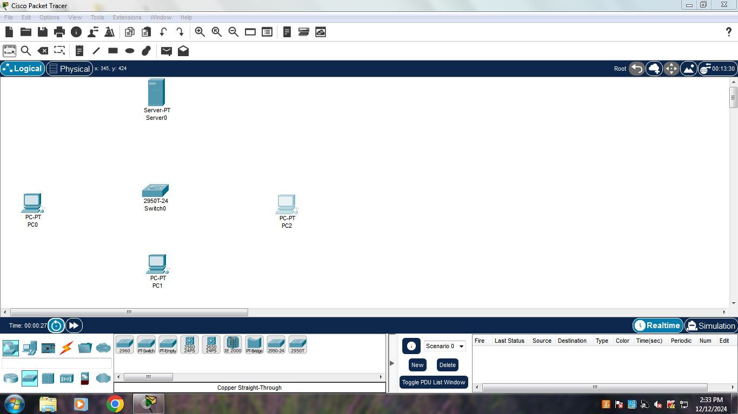

*Fig 1. Setting up PCs, switch and servers*

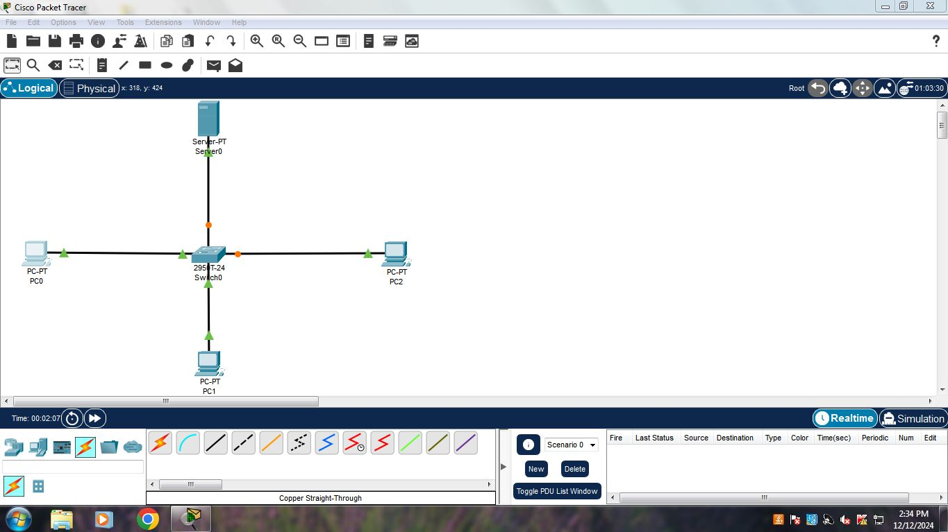

*Fig 2. Establishing connections*

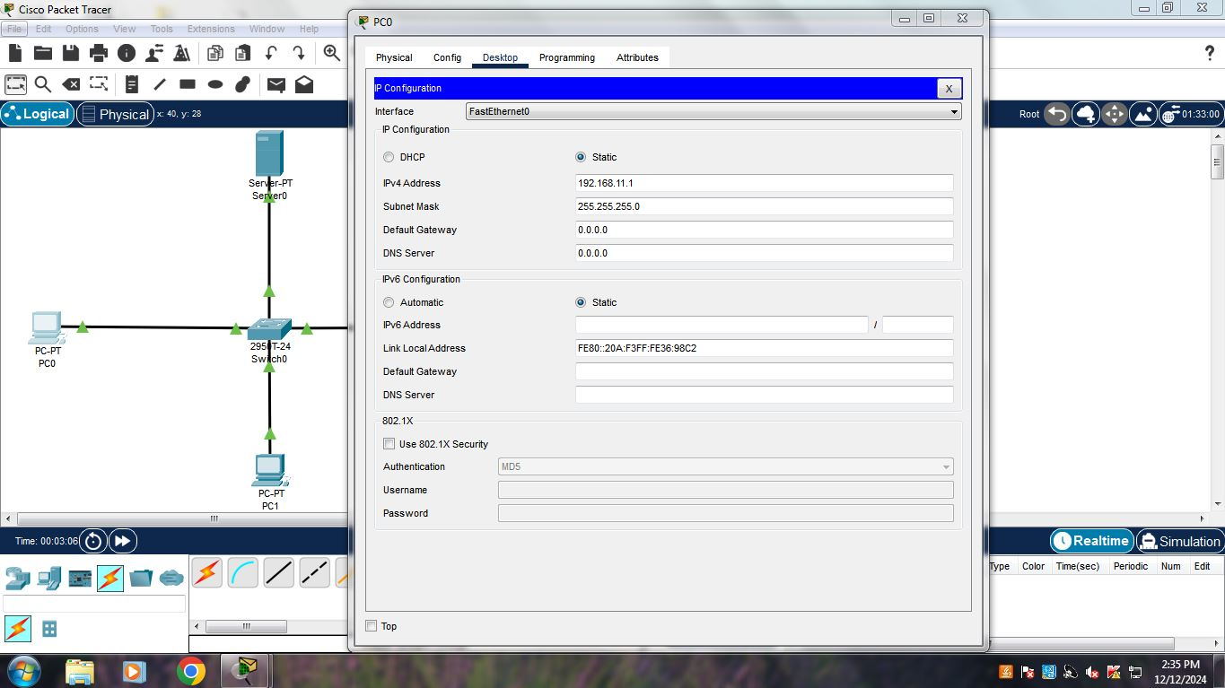

*Fig 3. Assigning IP Addresses to all PCs*

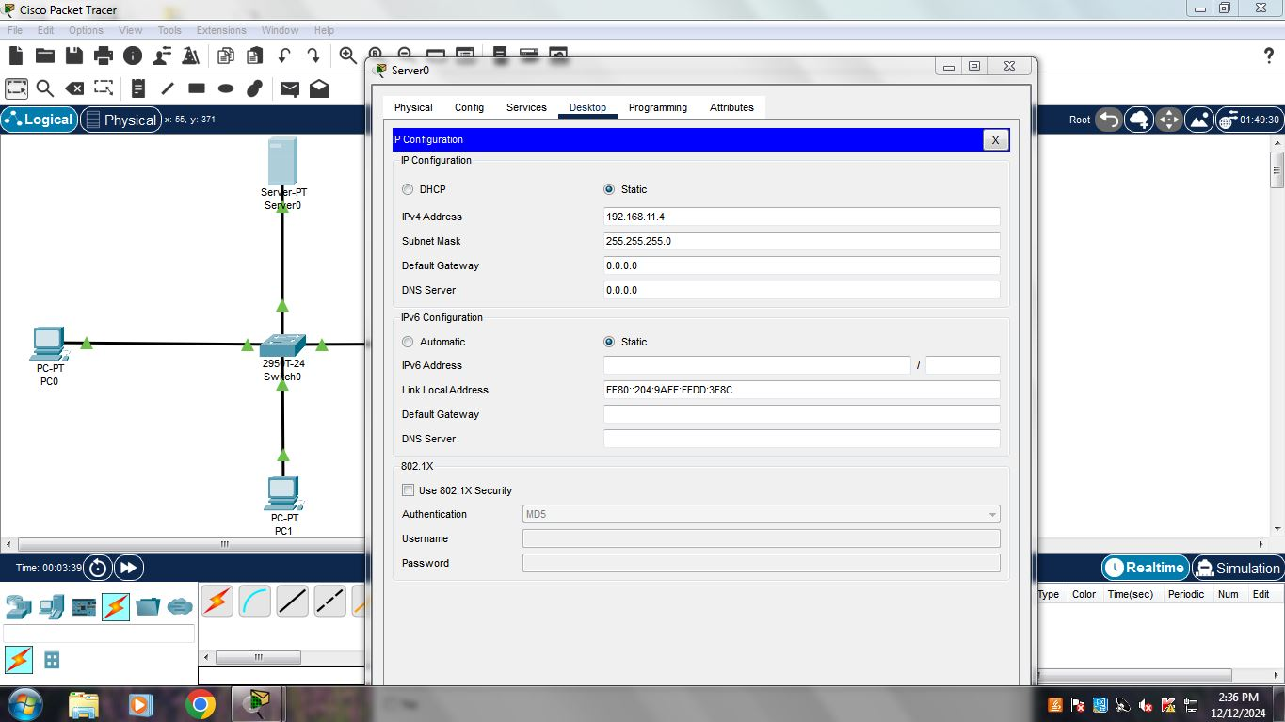

*Fig 4. Assigning IP Address to Server*

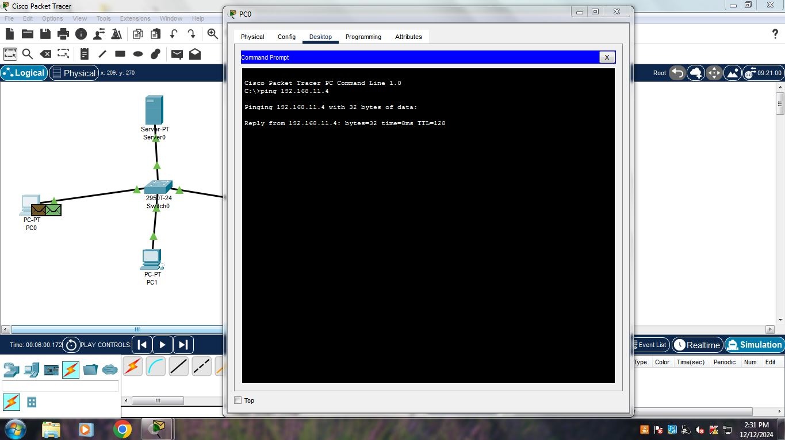

*Fig 5. Sending Pinging request*

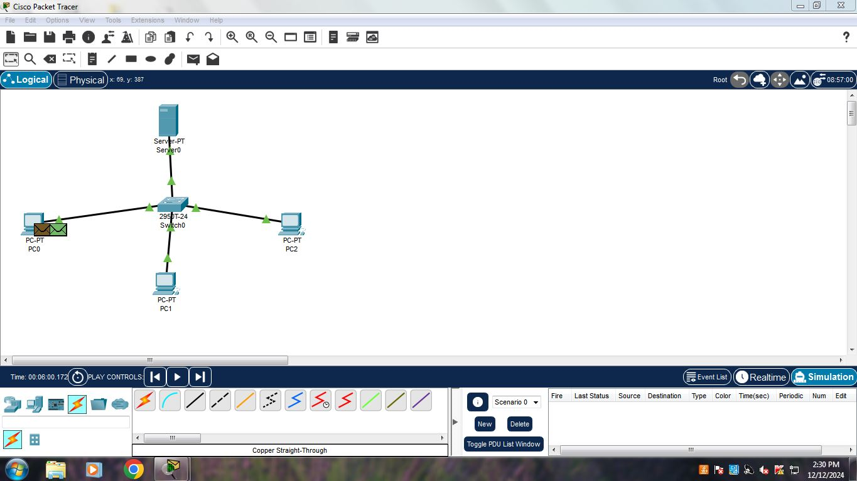

*Fig 6. Packet at source*

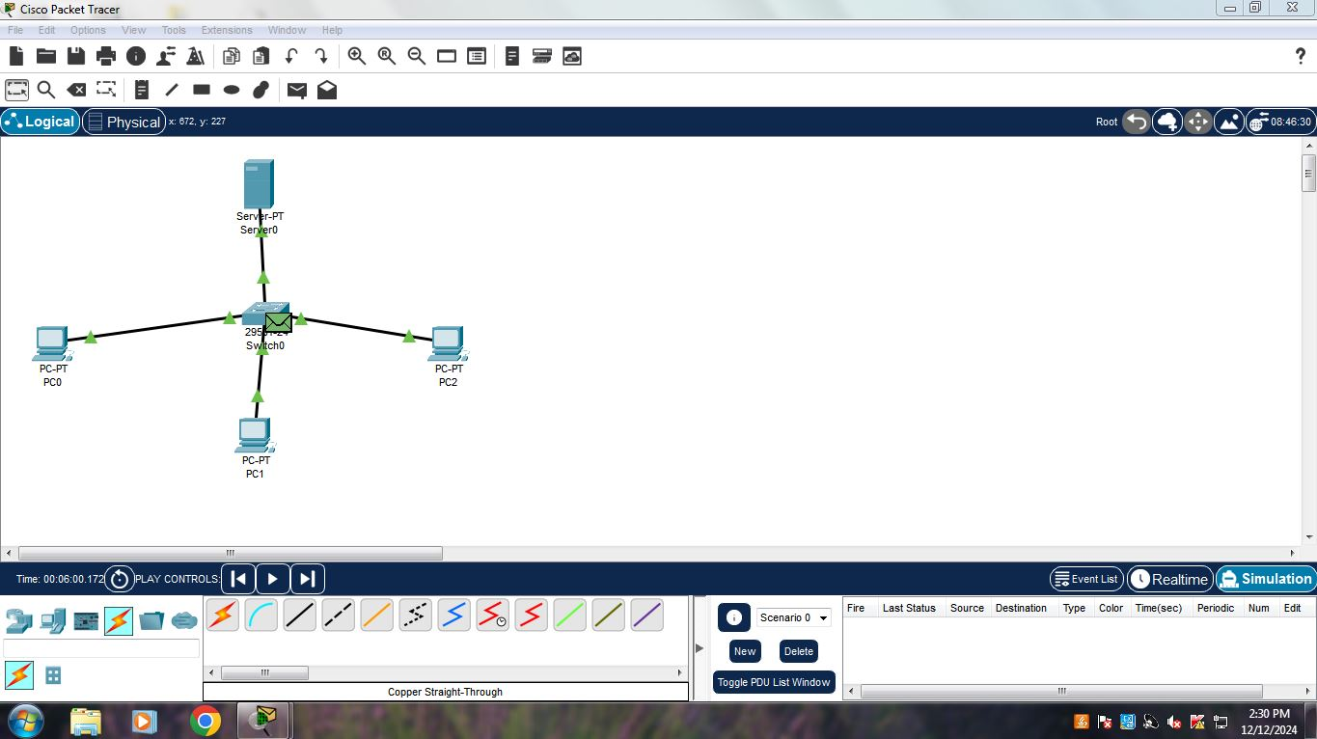

*Fig 6.1. Packet received by switch*

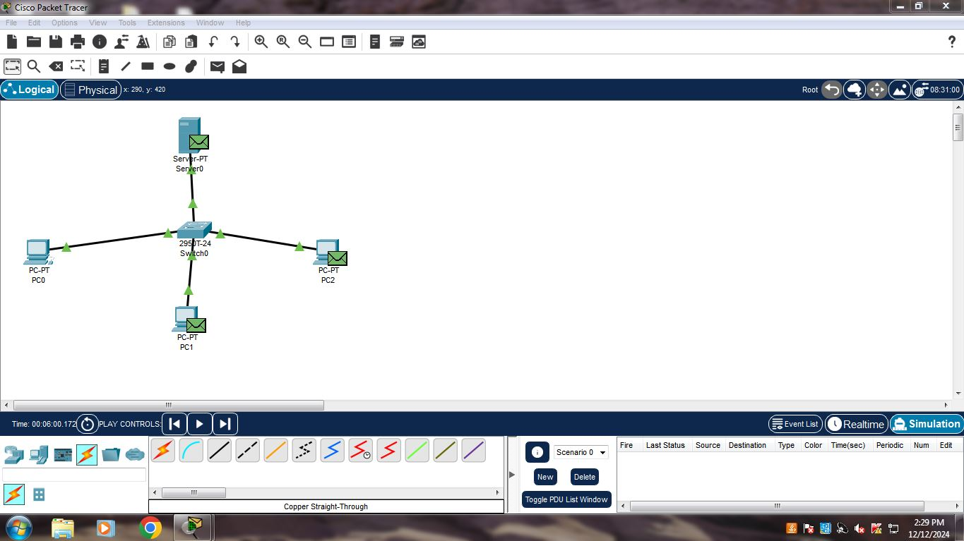

*Fig 6.2. Packets moved from switch*

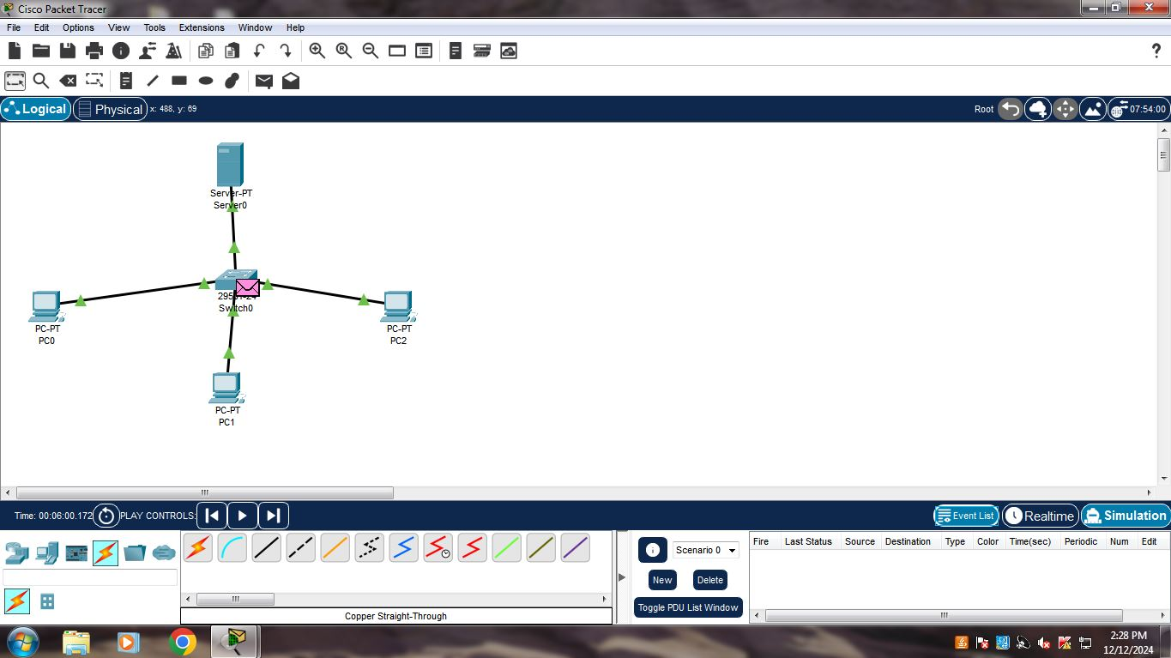

*Fig 6.3. Reply from destination*

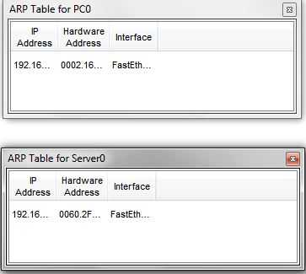

*Fig 7. ARP Table for PC0 and server*

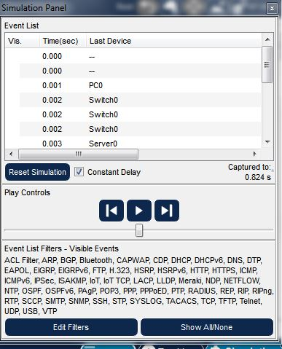

*Fig 8. Simulation Panel*

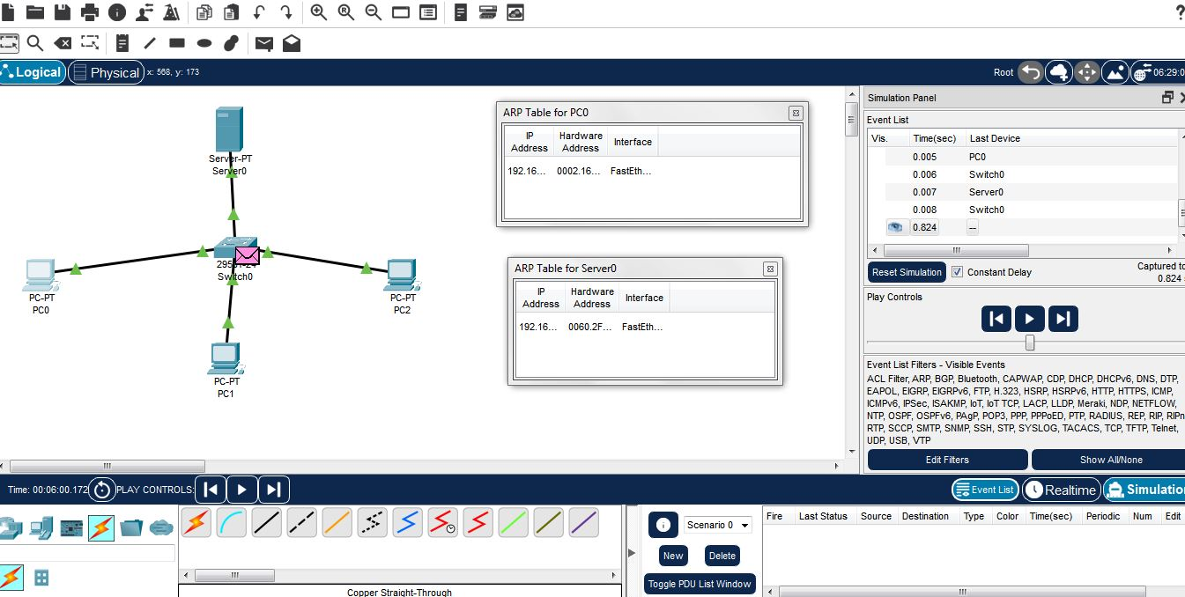

*Fig 9. Visualizing ARP and RARP Processes in a Network Simulation*

CONCLUSION

By simulating ARP and RARP in Cisco Packet Tracer, we've gained a practical understanding of these fundamental network protocols. We've visualized how devices discover each other's MAC addresses through ARP requests and replies. This knowledge is essential for network administrators to troubleshoot connectivity issues, such as when a new device is added to a network or when an existing device fails to communicate.

For example, when you connect a new device to your home network, it uses ARP to learn the MAC addresses of other devices on the network. This allows it to send data packets directly to the target devices, improving network performance.

Additionally, understanding ARP and RARP helps in troubleshooting network security issues. Malicious attacks like ARP spoofing can disrupt network traffic by sending false ARP replies. By understanding the normal behavior of ARP, network administrators can identify and mitigate such attacks.

By mastering these concepts, we can effectively address network challenges and ensure seamless communication within our digital world.

REFERENCES

**Textbooks:**

1. **Computer Networking: A Top-Down Approach** by James Kurose and Keith Ross
2. **Network+ Certification Guide** by Mike Meyers

**Online Resources:**

1. **Cisco Learning Network:** This official Cisco platform offers a wealth of resources, including courses, tutorials, and documentation.
2. **YouTube Tutorials:** Numerous YouTube channels provide tutorials on network fundamentals, including ARP and RARP.
3. **Network Simulator 3 (NS3):** While not directly related to Cisco Packet Tracer, NS3 is an open-source network simulator that can be used for more advanced network simulations, including ARP and RARP.